Data Modeling & Architecture Documentation

1. Business Context
Our platform provides digital content (articles, videos, posts) to customers. We monetize via:
- Subscriptions – Free, Monthly, or Yearly plans.
- Advertising – Revenue generated whenever a user clicks on ad-embedded content.
The business requires visibility into:
- Which content drives the most engagement.
- Revenue breakdown (ads vs subscriptions).
- Subscription churn and growth.
- Contents posted but never engaged.
- Customer journey insights across platforms.

2. High-Level Architecture
- Data Extraction: Python scripts pulling from multiple sources (e.g., Freshsales API, YouTube API, local CSVs).
- Data Storage: Snowflake (main warehouse).
- Transformations: dbt (incremental models, staging, marts).
- Orchestration: Airflow (scheduled ETL + notification alerts).
- Analytics & Reporting: PostgreSQL (for serving curated marts), Power BI for dashboards.

Architecture Image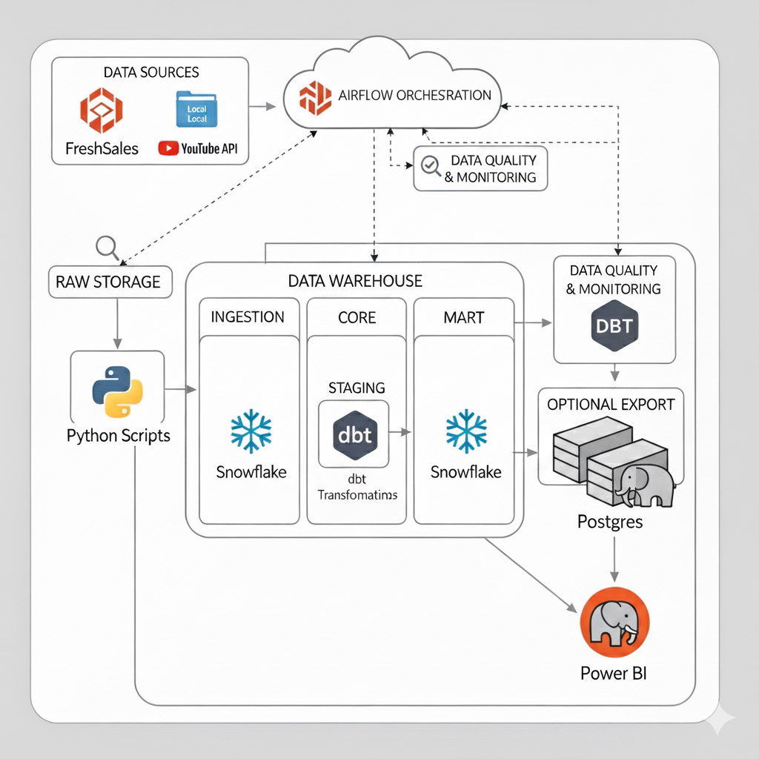

3. Data Modeling Approach
We use a Star Schema design with multiple fact and dimension tables. Granularity is carefully defined to support both revenue analysis and engagement tracking.
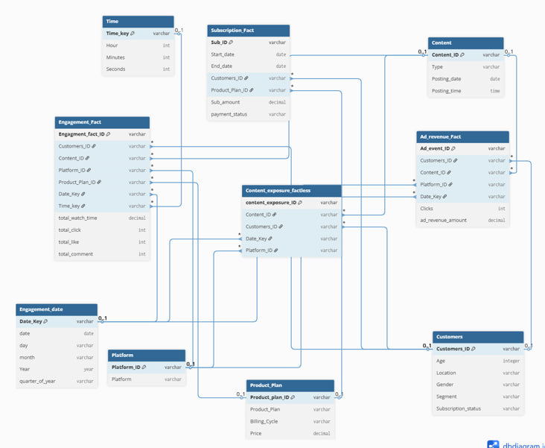
3.1 Fact Tables
- Engagement Fact
  - One row per engagement event (e.g., click, view, like, share).
  - Measures: engagement_count, watch_time, click_through_rate.
  - Keys: content_id, customer_id, platform_id, engagement_date_key, engagement_time_key.
- Subscription Fact
  - One row per subscription instance (monthly or yearly).
  - Measures: subscription_fee, churn_flag, renewal_count.
  - Keys: customer_id, plan_id, start_date_key, end_date_key.
- Ad Revenue Fact
  - One row per ad impression/click that generated revenue.
  - Measures: clicks, impressions, ad_revenue_amount.
  - Keys: content_id, platform_id, customer_id, date_key, time_key.
- Factless Engagement Table
  - Tracks occurrence of events without numeric measures.
  - Enables queries like “Which contents were posted but never engaged?”.
  - Keys: content_id, customer_id, posting_date_key, engagement_date_key, platform_id.

3.2 Dimension Tables
- Customer Dimension
  - Attributes: demographics, signup date, region, status.
- Content Dimension
  - Attributes: title, type (article, video, post), category, tags.
- Platform Dimension
  - Attributes: source system (YouTube, Website, Mobile App).
- Product Plan Dimension
  - Attributes: plan type (Free, Monthly, Yearly), price.
- Date Dimension (shared across facts)
  - Attributes: day, week, month, quarter, year.
- Time Dimension
  - Attributes: hour, minute, second.

4. Granularity
- Engagement Fact → One row per engagement event per customer per content per platform per timestamp.
- Subscription Fact → One row per subscription per customer per plan per period.
- Ad Revenue Fact → One row per ad click or impression event.
- Factless Table → One row per content posting & engagement event (or non-event).

5. Data Pipeline Flow
- Extraction (Python scripts):
  - Scripts authenticate and fetch from APIs (FreshSales, YouTube, CSV).
  - Extracted raw data stored in Snowflake staging schema.
- Transformation (dbt):
  - stg_* models: Clean & standardize raw tables.
  - int_* models: Join staging + apply business rules (subscription periods, ad revenue logic).
  - fct_* and dim_* models: Final fact/dimension tables for analytics.
- Loading:
  - Curated marts pushed from Snowflake → PostgreSQL.
  - Power BI connected to Postgres for dashboards.
- Orchestration (Airflow):
  - Daily ETL pipelines with retry logic.
  - Notifications for success/failure sent to email/Slack.

6. Data Governance
- Keys: Surrogate keys (content_id, customer_id, date_key, time_key).
- Slowly Changing Dimensions:
  - Customer Dimension → SCD Type 2 (retain historical changes).
  - Product Plan → SCD Type 2 (track plan upgrades/downgrades).
- Null Handling: Default unknown values (Unknown, N/A, 0).
- Partitioning: Revenue and engagement facts partitioned by date_key.

7. Future Improvements
- Add Marketing Campaign Dimension for attribution analysis.
- Incorporate AI-based recommendation fact table.
- Build real-time streaming pipeline for instant engagement tracking.
- Add cost fact table to calculate true ROI.

